Environmental Arts & Humanities

The following programs were contacted for a concurrence. Those highlighted in green concurred. Those in yellow did not respond to the concurrence request. They were individually contacted on October 6, 2021 and informed that after two weeks a concurrence would be assumed. No program declined to give a concurrence.

African American and African Studies
Anthropology
Art
Arts Administration
Astronomy
Chemistry
Classics
Comparative Studies
School of Communication
Dance
Design
Department of East Asian LL
Economics
English
EEOB
French
Geography
Germanic LL
History of Art
History
Linguistics
Mathematics
Microbiology
Molecular Genetics
Music
NELC
Philosophy
Physics
Political Science
Psychology
Slavic
Sociology
Spanish
Speech and Hearing Science
Statics
Theatre
WGSS

Business
Engineer
Food, Ag
Law
Public Health

Arts Admin

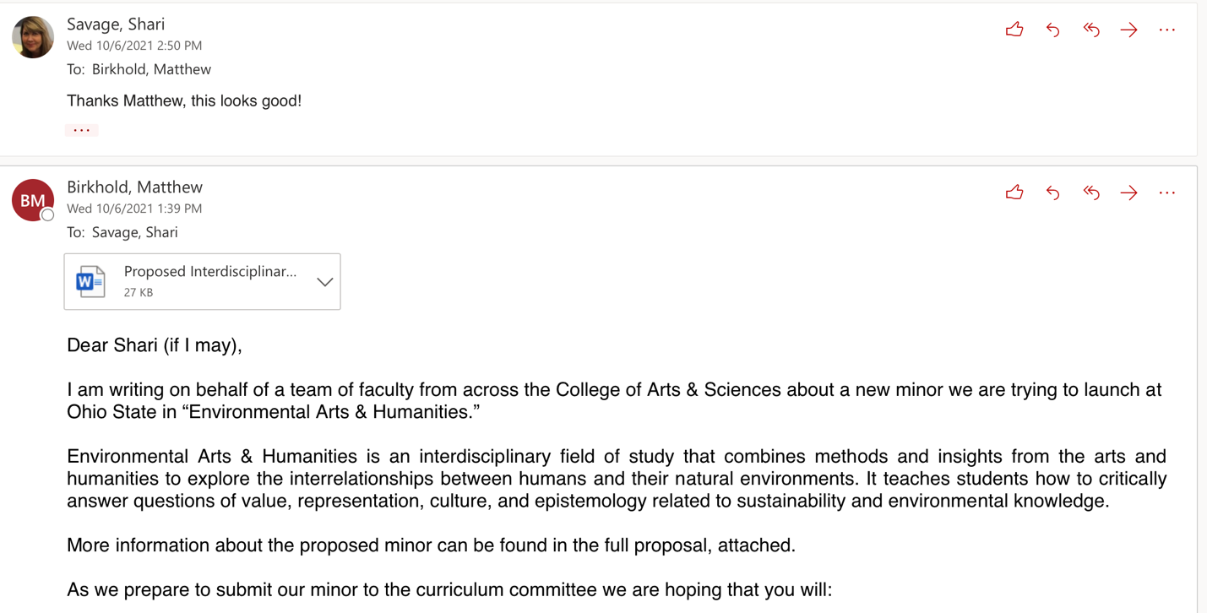

Classics

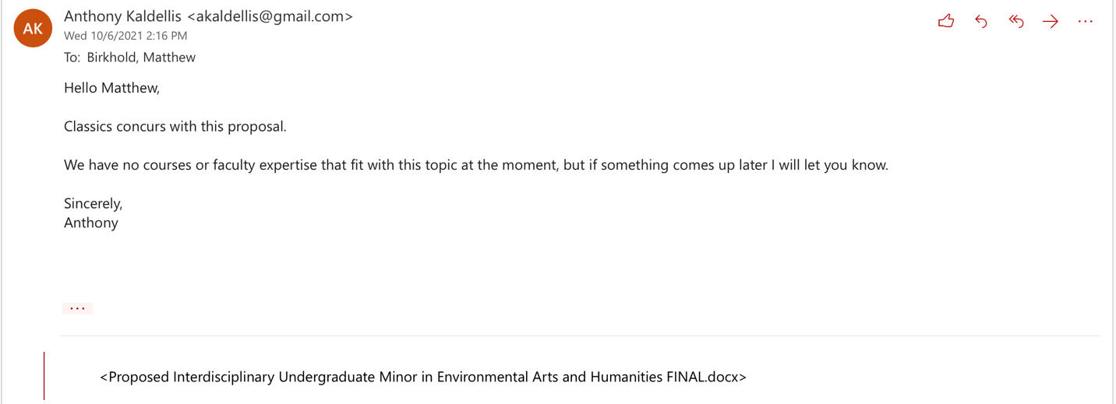

Communication

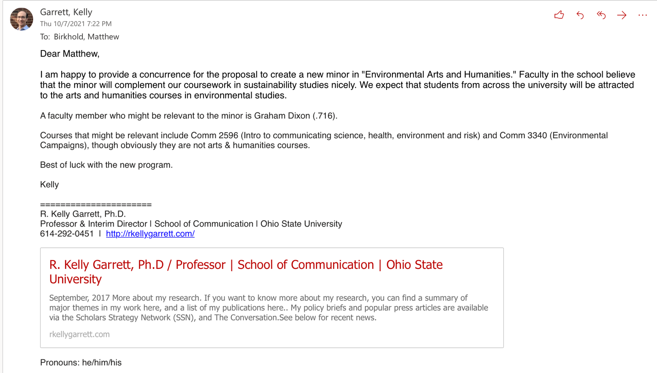

Dance
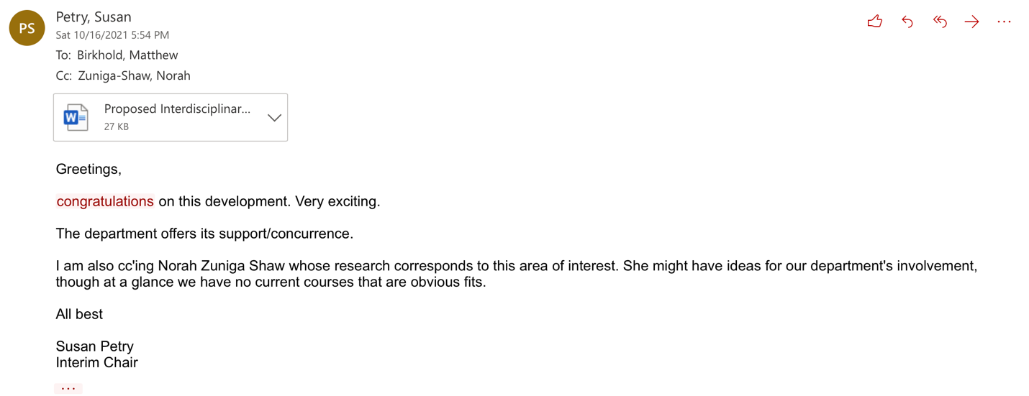

DEALL

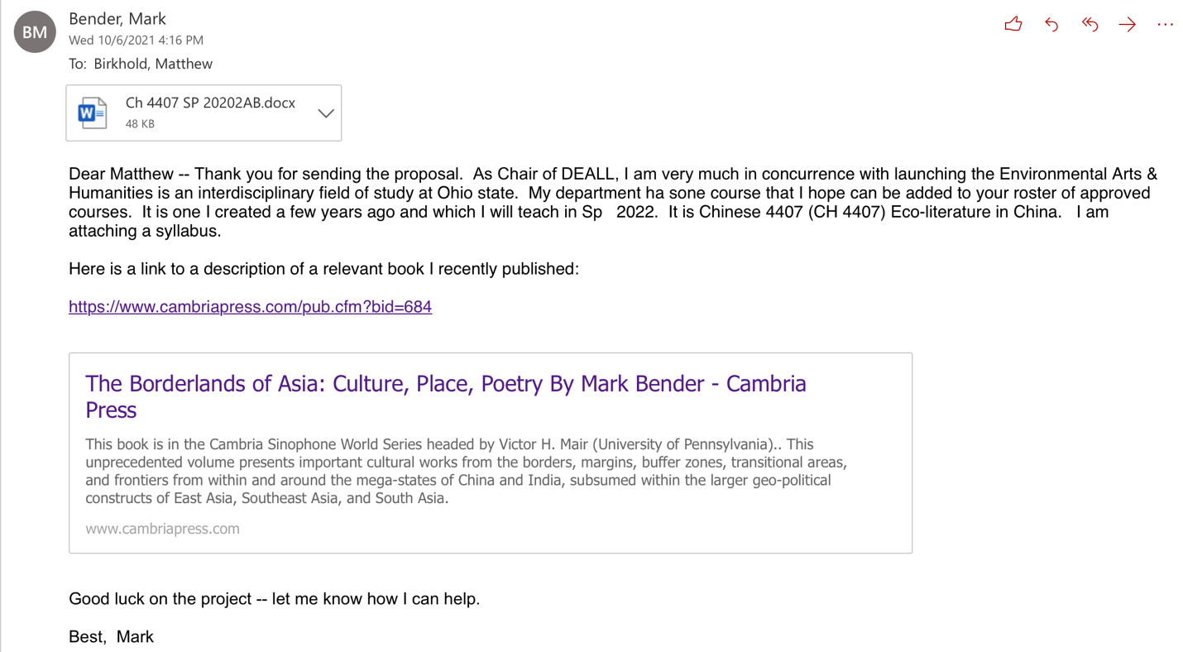

EEOB

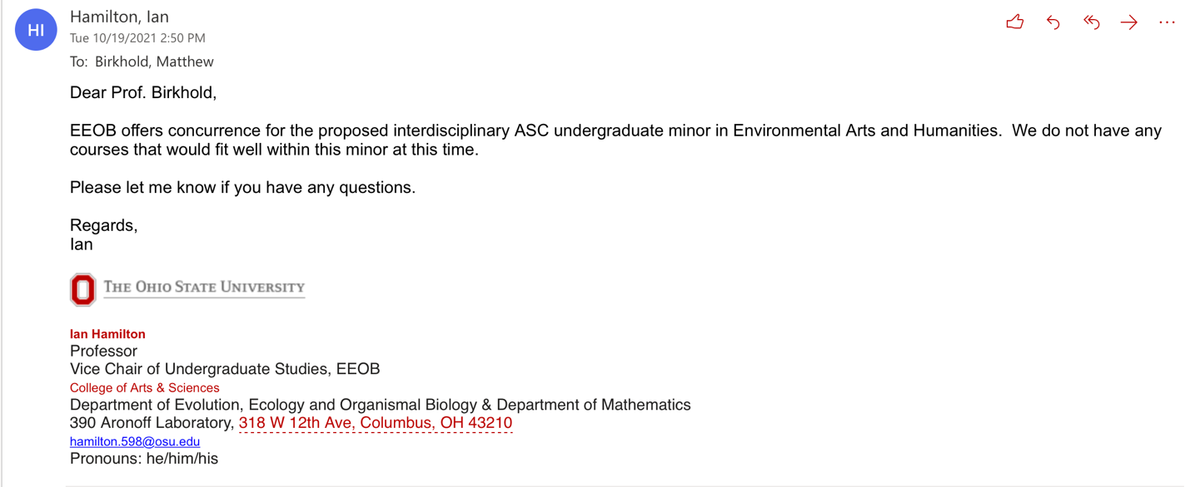

English

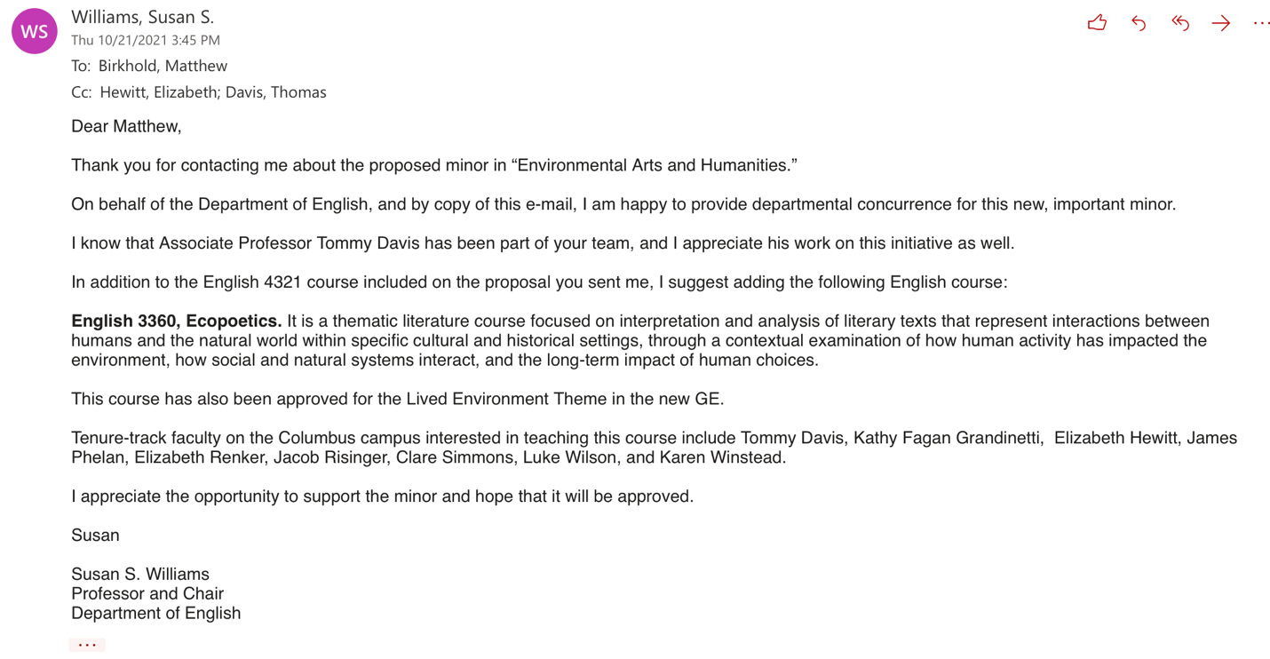

FRIT
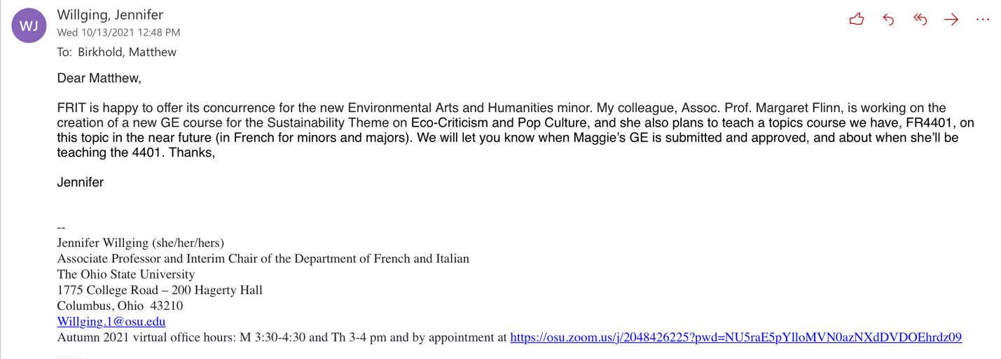

GLL

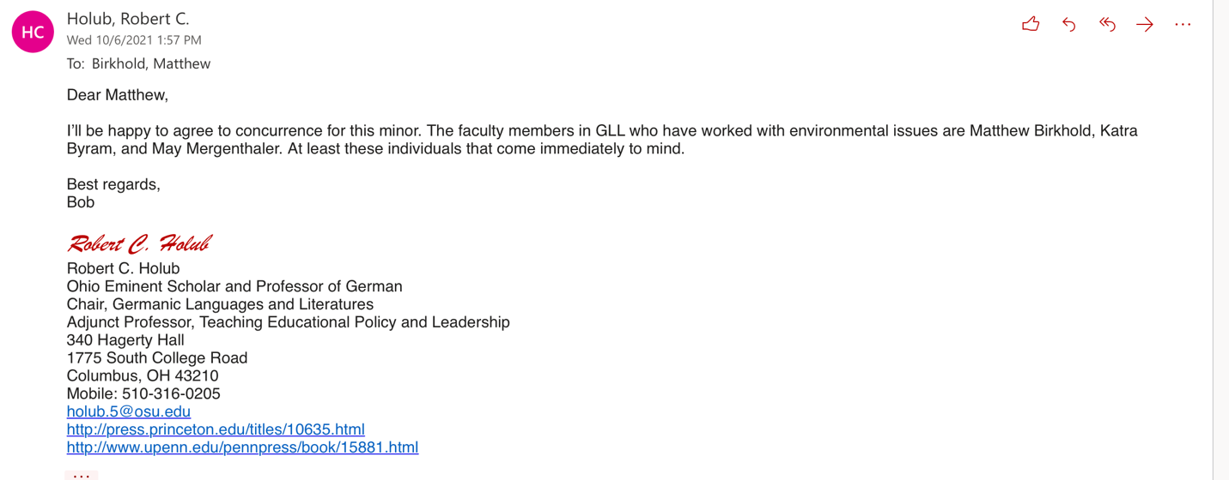

Geography

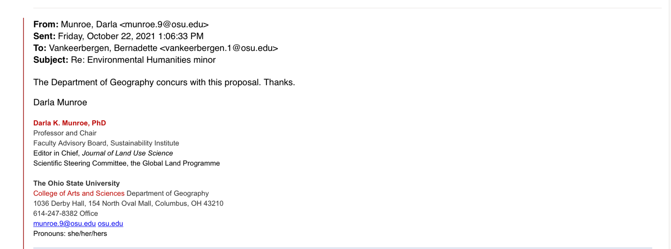

History

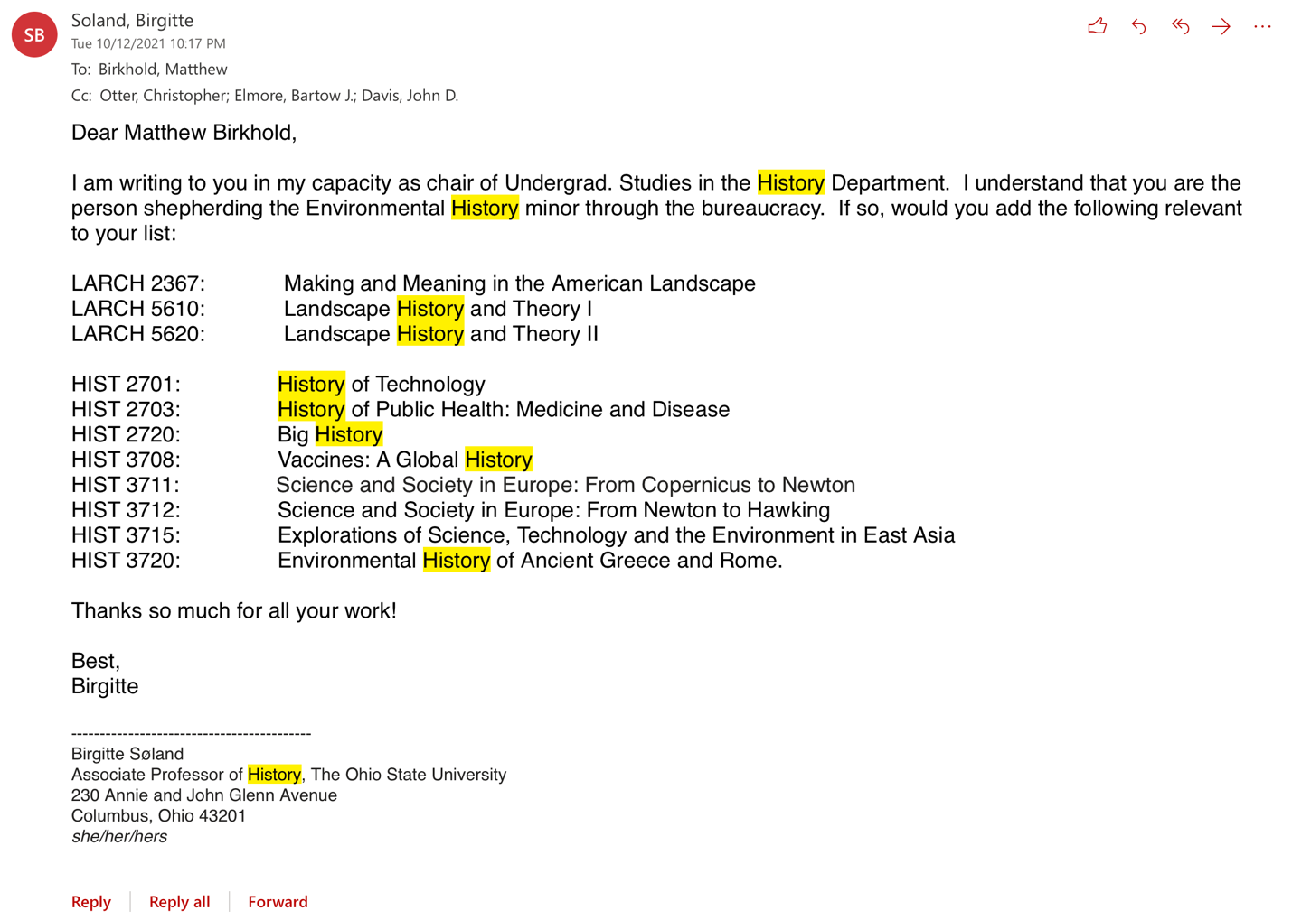

History of Art

Linguistics

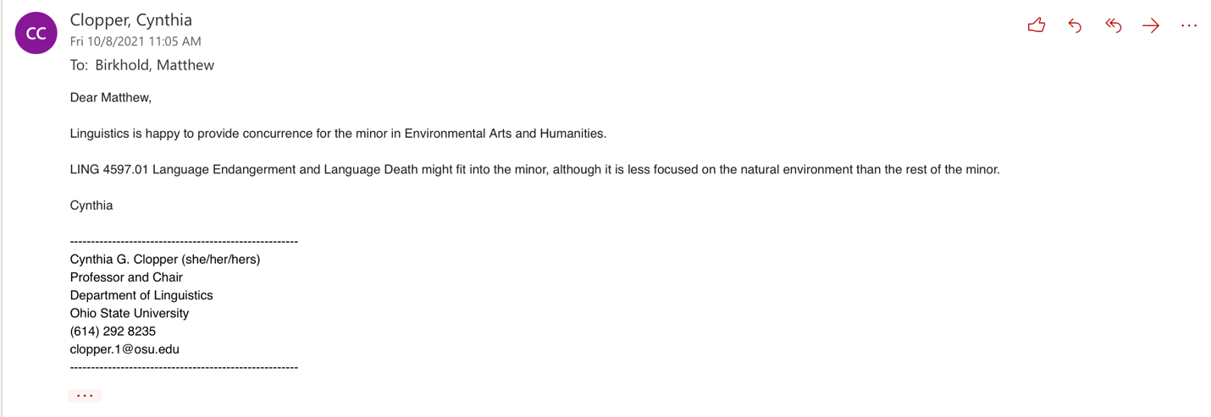

NELC

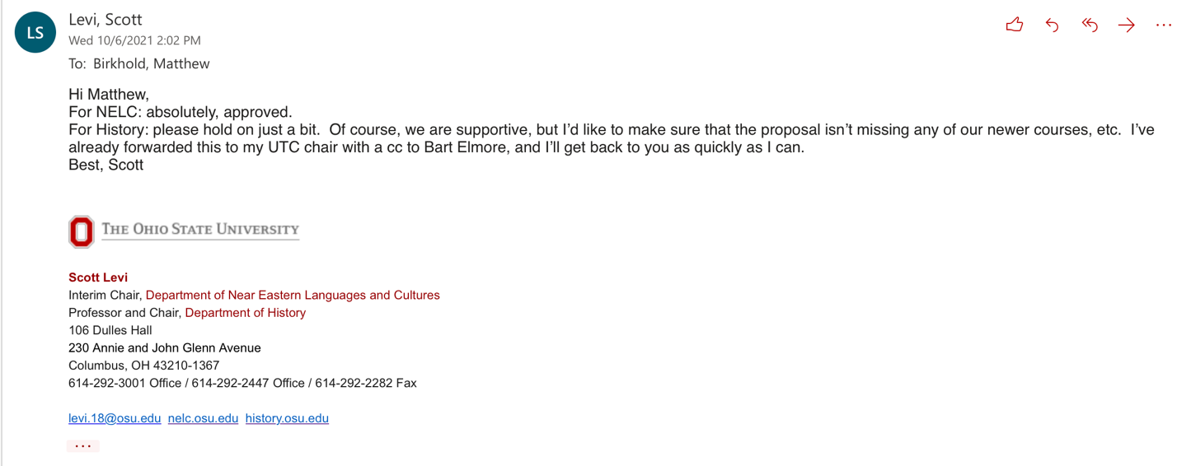

Philosophy

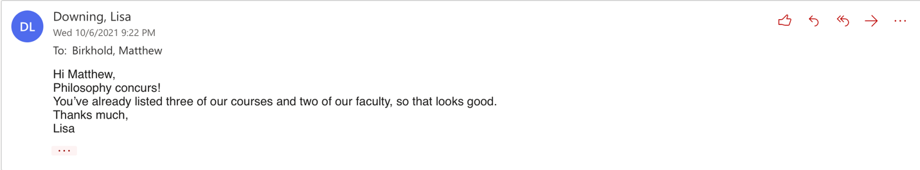

Slavic

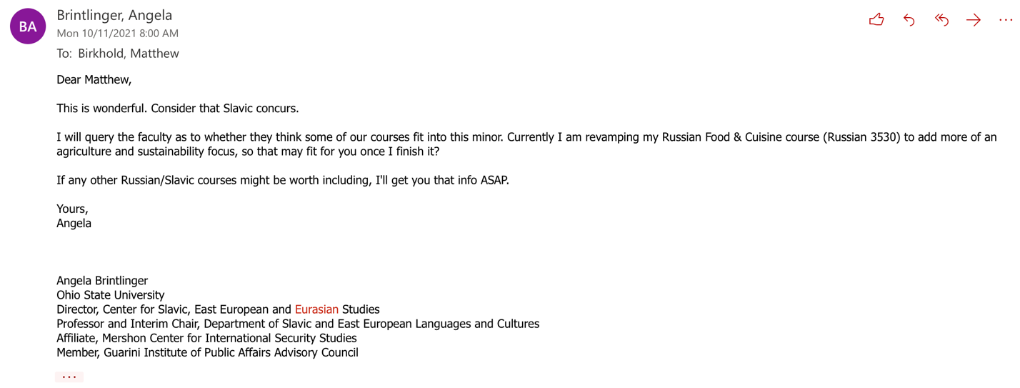

Sociology
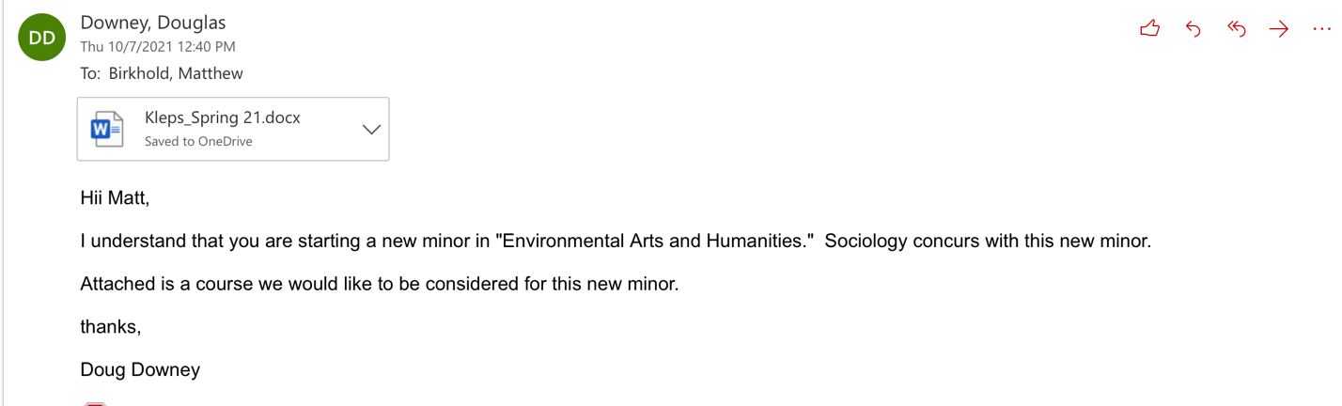

Spanish

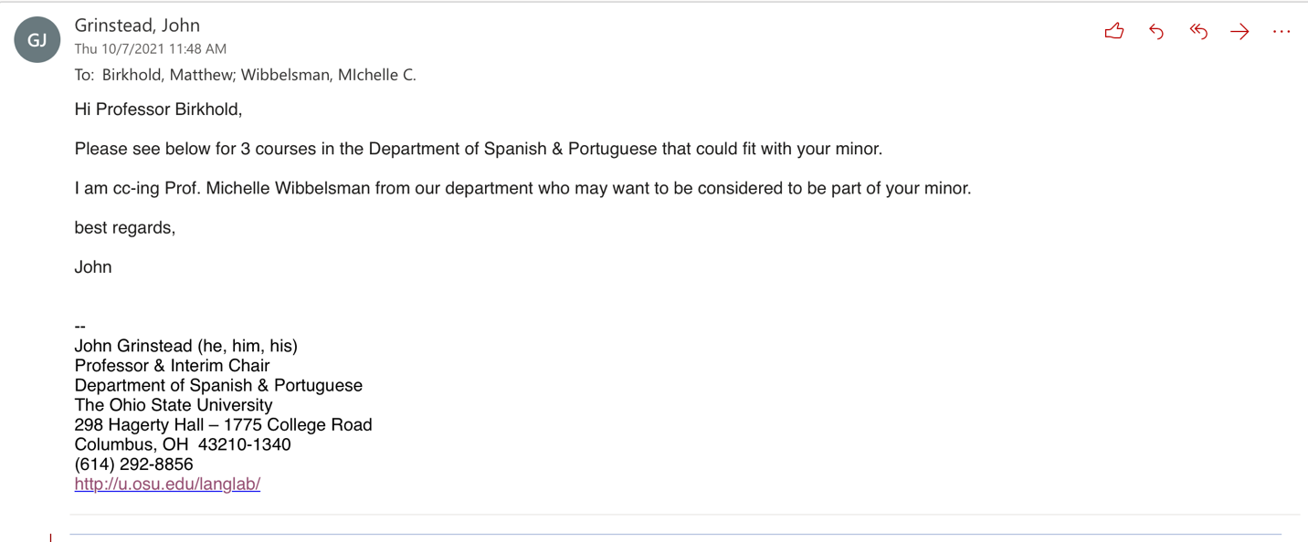

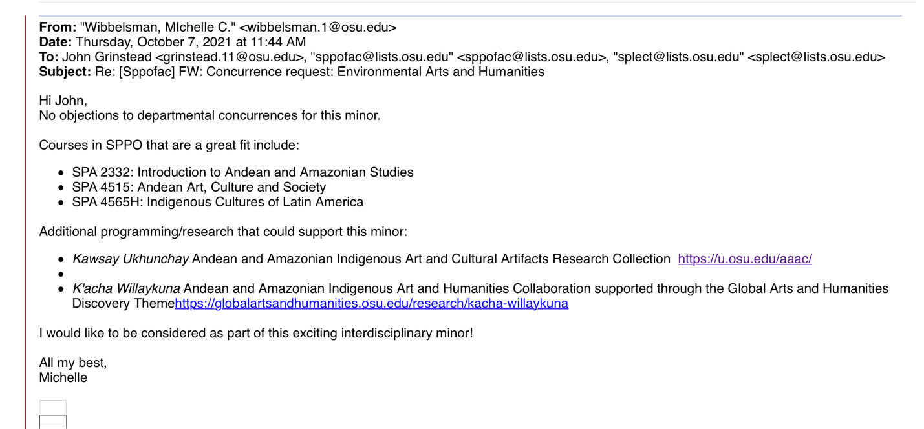

Theatre
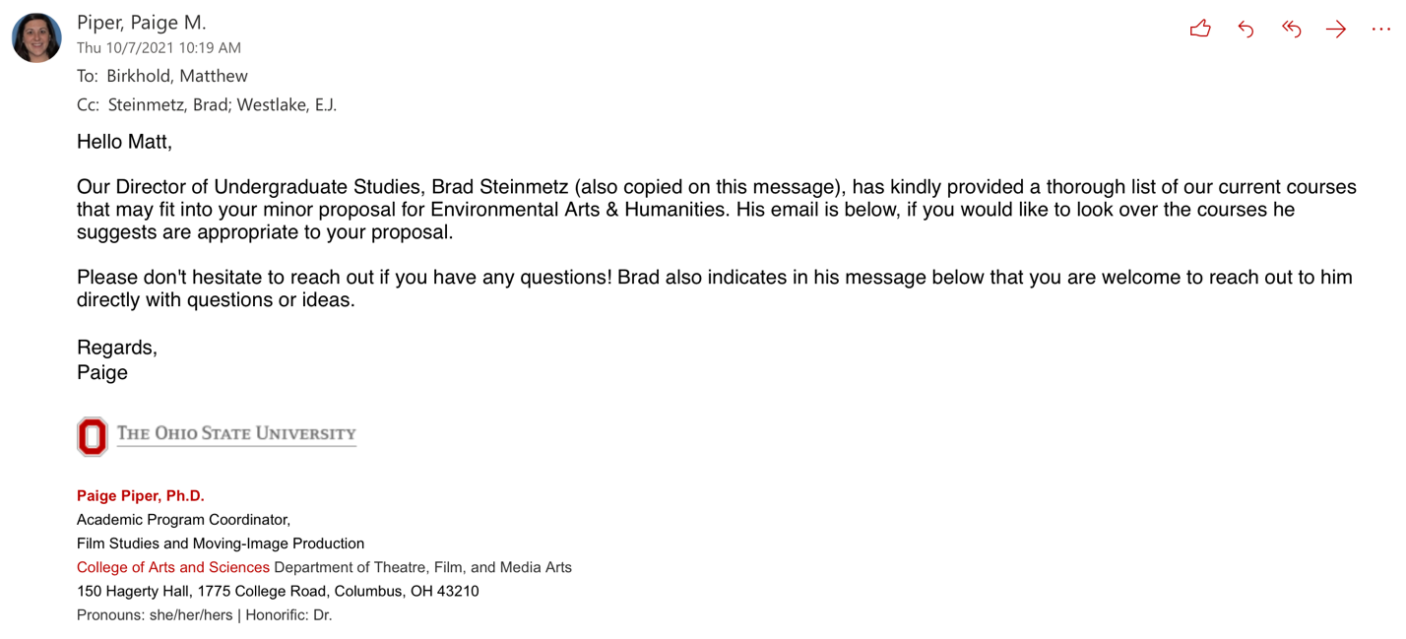

WGSS

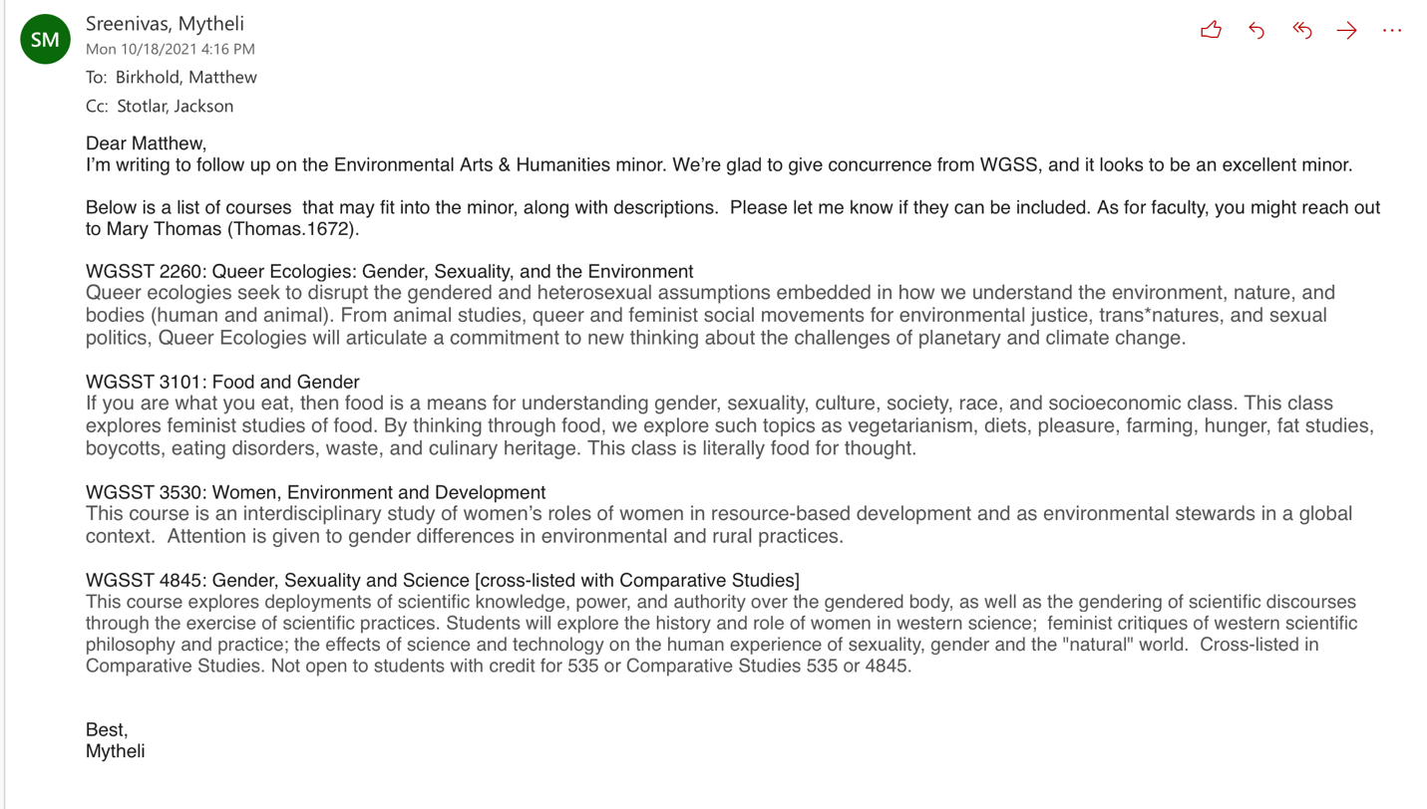

FAES

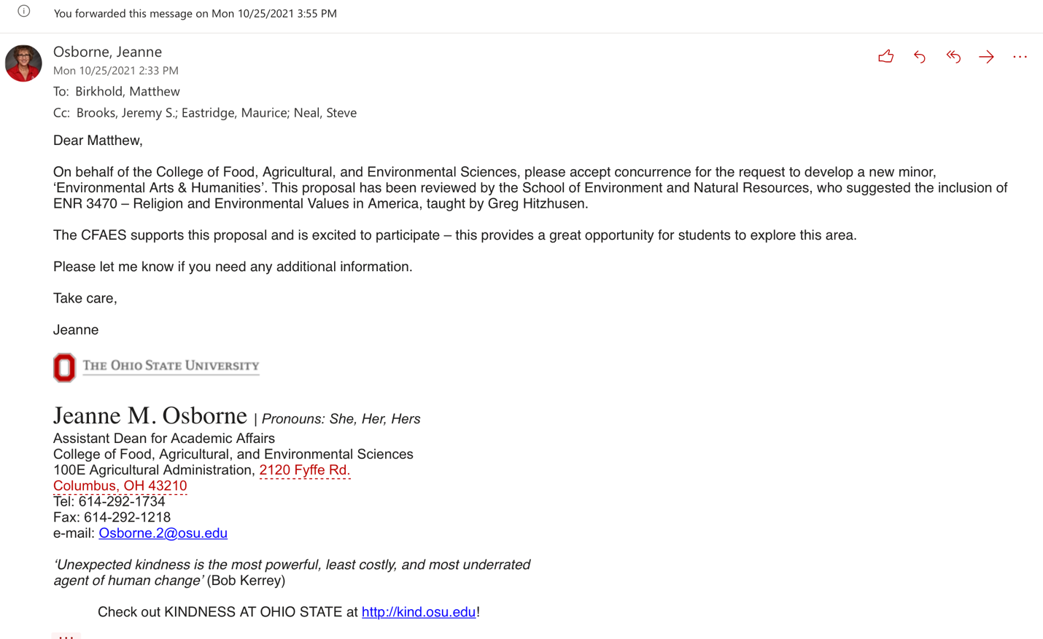

Law

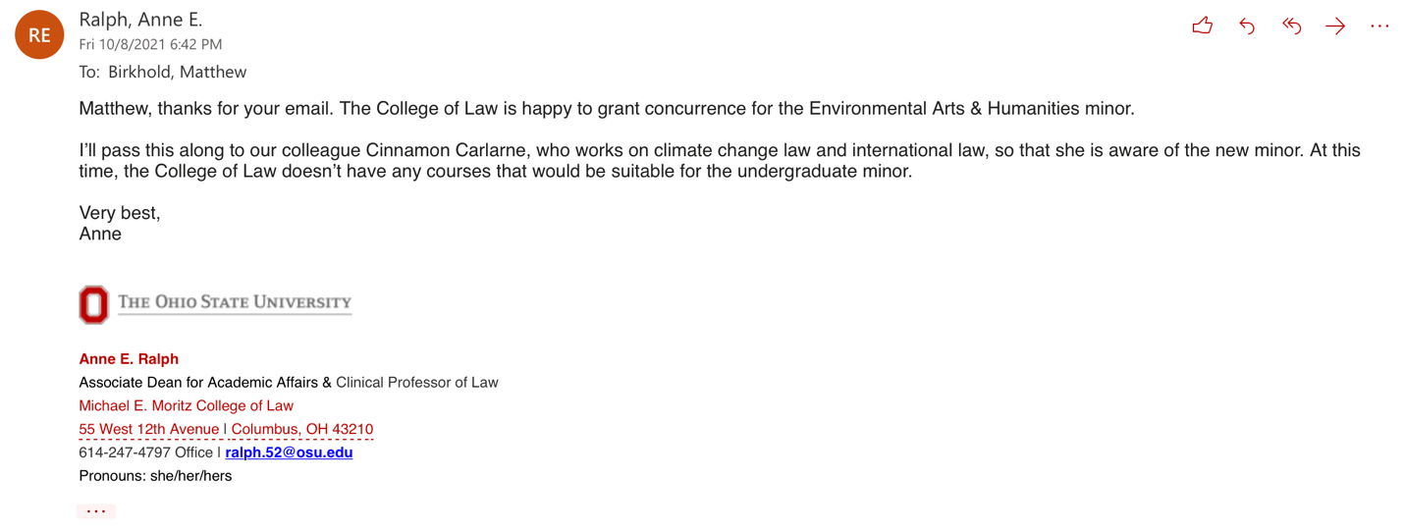

Programs e-mailed and no response heard:

